**Vietnam’s FMCG Beauty Contest: VNM versus SAB**

Vietnam is a fantastic consumption story. We all know that. But Vietnam’s consumption story is also perhaps one of the greatest sources of frustration for the EM/ FM equity investor. If you were to create a scatter plot of the EMs / FMs showing the degree of “mindshare” or interest that each country’s consumption story commands versus the representation of / access to the story via the universe of listed equities, Vietnam would be way off the trend line – access to the Vietnam’s consumption story for the listed equity investor is disproportionately lower than the interest it has garnered in recent years. Perhaps just a microcosm of the Vietnam narrative as a whole – a market which I love to describe as having “emerging market-like mindshare” with “frontier market-like accessibility”.

Save for the holy trinity of Vinamilk (VNM), Sabeco (SAB) and Masan Consumer (MCH), therefore, there are virtually no pure-play, classic FMCG names listed on the stock exchange. With MCH a more complex business to analyze (given its conglomerate parentage), the FMCG beauty contest in Vietnam would then have to boil down to VNM vs. SAB.

With the general flight to quality and investors contemplating a rotation into more defensive names, I thought this as good a time as any to see how these two FMCG giants stack-up against each other.

With a few quarters of – still rather inexplicable – sales weakness have taken the sheen off VNM, SAB seems to have taken center stage as a blue chip play on the Vietnamese consumer. Much like VNM, it is a behemoth in its space, a homegrown champion (implying strong government backing) and with a gigantic distribution machinery; also both companies have large foreign brand owners as strategic shareholders (VNM actually has two but I see F&N as the ultimate winner). But when you take a step back and think about the relative dynamics of the beer versus the dairy categories in Vietnam and the relative strengths and valuation of VNM and SAB, it appears to me that VNM is a superior long-term bet.

Let me tell you the story in pictures:

**Vietnam’s per capita beer consumption is already high relative to its average income level…**

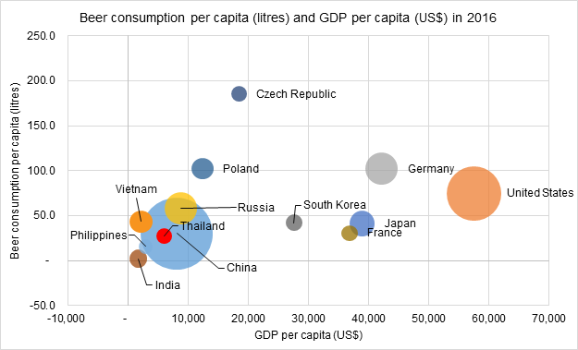

**…while Vietnam’s per capita milk consumption is roughly aligned with its average income level**

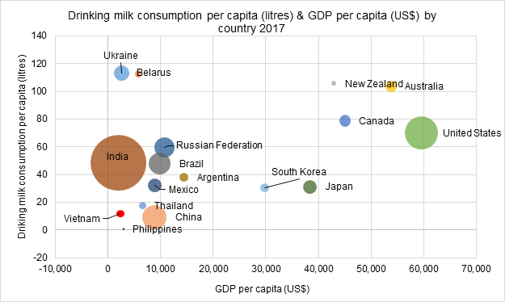

**The beer market has a greater presence of foreign brands than does the dairy market, implying greater competitive pressures for the domestic incumbent particularly in an era of product premiumization**

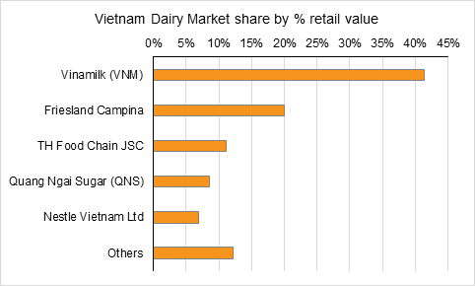

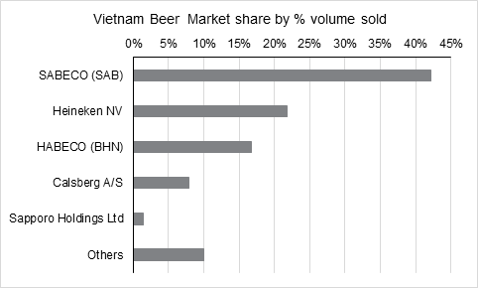

**VNM has a greater market share lead over its closest competitor than does SAB**



**Given that both VNM and SAB have large distribution networks and sizable foreign strategic shareholders, their ability to pump their foreign parent’s brands through their existing distribution machinery could be a major future value driver**

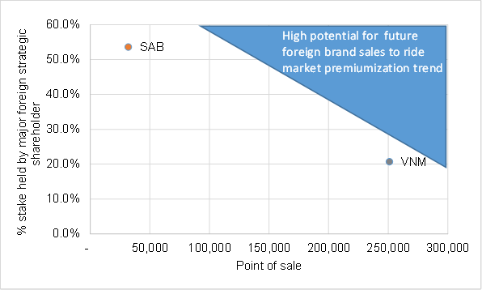

**VNM’s substantially larger distribution network is not reflected in its valuation, relative to SAB**

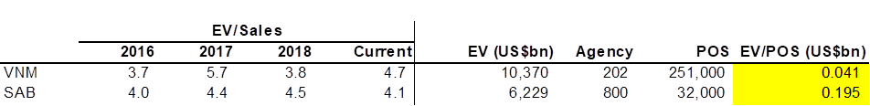

**If you believe that VNM’s recent earnings decline is just transitory, such a steep valuation discount to SAB might be unwarranted**

