**VNDirect Research Blurb: Vietnam’s smartphone curse + it’s not about a trade truce, stupid.**

It would seem like a bad idea these days to have one-fifth of your total exports be comprised up of mobile handsets (sorry, Vietnam). The barrage of bad news in the smartphone industry continues unabated – first Apple warned of a sharper-than-expected slowdown in China on its weak sales, then Samsung Electronics announced its pre-earnings guidance for 4Q18, with revenue and OP falling short of expectations and memory and smartphone sales touted as the biggest culprits for the earnings miss.

Then, a new report from Counterpoint found that global smartphones sales fell for the first time by 3% in third quarter of 2018 after growing by an average of 16% over the past five years. Full year shipment volumes are expected to clock a 1% fall in 2018. What is particularly jarring is the contradiction between the siren song of a “strong consumer” globally and the newfound weakness is what could really be considered a bellwether of consumer sentiment, i.e., smart phone demand.

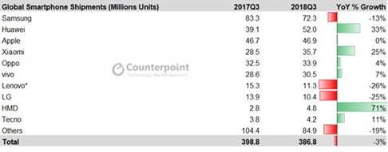

***Source: Counterpoint***

Maybe the pronounced economic slowdown in China and a trade-war induced wet blanket on Chinese consumer sentiment is stretching out smart phone replacement cycles – after all, when the economy looks like it’s going down the tube and your stock portfolio is down 20%, you can afford to delay that smartphone upgrade by a few months. If you are an optimist, therefore, the smartphone sales weakness is China-led and transitory in nature. But what should concern Vietnam-watchers is not so much the system-wide slowdown in handset sales but, rather, Vietnam’s “Samsung-concentration risk” which was pointed out in our report from last year where we argued that **Vietnam’s success story in handset manufacturing for Samsung could well be its Achilles Heel – that report, titled, “Vietnam’s electronics export boom comes with hidden risks” can be downloaded** [**here**](https://static-02.vndirect.com.vn/uploads/prod/Macro-Note-Vietnam-20180315.pdf)**.**

**Samsung concentration risk coming home to roost?**

cid:image005.png@01D4AC35.FFF00070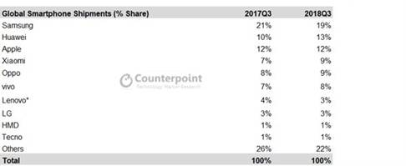

***Source: Counterpoint***

As shown above, Samsung is fast losing its dominance in the global smartphone market and this decline seems particularly acute in large emerging markets like China and India wherein the increasingly feature-rich yet cheaper Chinese brands like Xiaomi, Oppo, Vivo and Huawei have come up with compelling value proposition for price-sensitive (Indian) and increasingly nationalistic (Chinese) consumers. China’s newfound ostracism from the Western-led technology order is only deepening the moat around the “digital Galapagos” that is China’s internet economy, with the result that native apps developed and / or pre-loaded by the Chinese smartphone makers that are uniquely tailored to a Chinese digital context are giving them that additional edge over Apple and Samsung.

Samsung’s smartphone business could, therefore, be in terminal decline. Good news then that Foxconn appears to have entered into talks with the Vietnamese authorities about potentially setting up an iPhone manufacturing unit in Vietnam. But with Apple seeming to have also lost its magic touch (Tim Cook is clearly not Steve Jobs) in churning out new blockbuster products and now looking to focus on a range of cheaper phones to crack the emerging market consumer, I doubt that Foxconn’s imminent entry into Vietnam is cause for cheer. Vietnam’s cultural hostility to China (stoked by the occasional flare up of tensions over the South China Sea), also makes the country particularly vulnerable to the changing balance of power in the smartphone manufacturing industry – Vietnam’s government might have to think twice before it rolls out the red carpet for the Chinese handset makers who seem destined to dominate the trade in the next few years.

Vietnam’s handset export dependence on a declining industry player is starting to tell now in the export numbers – have a look at the chart below.

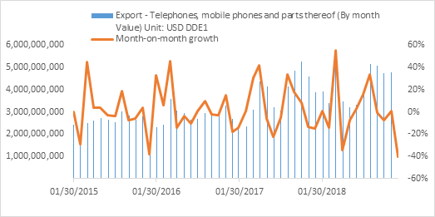

So, should you despair? Not just yet.

**Vietnam might have just received the lease of life it needs to reduce its outsized dependence on smartphone exports to fuel its overall electronics export miracle.**

Yes, I am referring to the US-China trade tensions. Enough has been written about Vietnam being an outsized beneficiary of the trade war – but I just want to point out a couple of things:

1. **The talk is translating to action:** I recently came across a media report about this year’s Consumer Electronics Show (CES) which just wrapped up in Las Vegas. The CNN journalist who was covering the event spoke extensively to CEOs attending the trade show this year. His takeaways were simple – a) Trade-war related concerns abounded, and b) the two country names he heard being mentioned most often as destinations for factory relocation were Vietnam and Cambodia (yes the second one was a bit of a surprise). Clearly, the anticipated surge in electronics manufacturing investments in Vietnam – away from just handsets and into a broad spectrum of consumer electrical appliances and white goods – is looking real.

1. **A trade-war resolution is not going to derail the story:** Industrial park and logistics stocks in Vietnam got a nice lift late last year as the trade war deepened and expectations of a mass exodus of export manufacturing from China took hold. As prospects of a temporary trade war deal dawned, the wind seemed to reverse out of the “trade war beneficiary” sails and these very same stocks saw their price gains reverse. The “trade-war beneficiary” trade seems to have gone out of fashion now as the US and China inch closer to some sort of trade deal. But I think this is myopic for two reasons:

* 1. **The trade war has been a major wake-up call to US supply chain and procurement managers.** It is clear to all that the trade war is part of a great power rivalry that is likely to play out over the next few decades – the growing “weaponization” of trade means that another flare up in trade disputes is highly likely. A China-plus-one strategy, therefore, has never been more critical.

* 1. **The trade war only served to accelerate a structural shift that was long underway.** Factories have been moving out of China for years now owing to eroding cost advantages offered by the latter. Wages have risen sharply with Pearl River Delta factory workers earnings as much as 4-5 times as much as their Vietnamese counterparts. Growing environmental regulations in an increasingly pollution-paranoid China have piled on even more costs for manufacturers. The trade war only served to accelerate this trend rather than kick-starting it. Granted that in certain sectors like electronics manufacturing, China’s diminishing labor cost advantages could well have been countered by the growing “network effects” of an established ecosystem with the world’s largest base of suppliers and ancillary service providers. Hence, a trade truce between the US and China could well dent the pace at which manufacturing capacity in this sector moves out of China and into Vietnam but in several other sectors such as textiles and footwear, wooden products (toys, furniture, kitchen equipment), rubber products (gloves), I expect Vietnam to continue to see a deluge of FDI, trade war resolution notwithstanding.

The trade war has only brought into sharper relief the comparative advantages of ASEAN versus China in key sectors of the export manufacturing universe and investors would be served well by focusing on the long-term supply chain reconfiguration story rather than reacting, in knee-jerk fashion, to the prospects of any newfound Donald-Xi bonhomie. **If you want to learn about how Vietnam and other ASEAN countries fare in terms of competitiveness amongst themselves and versus China across the waste swathe of manufactured exports to the US, this report authored by yours’ truly could serve as a good starting point:** [**ASEAN STRATEGY: Near-term Pain for Long-term gain**](https://static-02.vndirect.com.vn/uploads/prod/ASEAN-Strategy_Near-term-pain-for-long-term-gain.pdf).

Anirban Lahiri

Head of Research