**The DPRK-US Summit + Dr. Google’s Prognosis for “Brand Vietnam”**

Six years ago when I stepped into the Melia Hotel in Hanoi for the first time, Hanoi felt like a regional backwater. Vietnam’s economy was in the doldrums, following a property sector crisis that infected the banking system and dented the currency. Investors had given up on the country – I remember a country head of Goldman Sachs of a major Asian emerging market telling me that Vietnam had “lost the plot” and I should consider upping sticks to China, instead.

Scarcely would I have imagined that the same Melia Hotel would be the centerpiece of attention a few years down the road and play host to one of the most notorious yet intriguing world leaders of our team, Kim Jong Un of North Korea.

Last evening as I strolled over towards the very same Melia Hotel, the sense of anticipation was palpable. Walking past the gigantic International Media Center created just to host journalists and reporters on the US-North Korea summit, I saw several familiar faces – the who’s who of the journalism universe, including heavyweight correspondents from the likes of BBC and CNN were found loitering around the entrance to the building, nervously puffing on the odd cigarette as their camera crew prepared fliming kit. Further down, near the entrance to the Melia, a fenced-off area was peppered with TV reporters chattering away in a whole host of languages – while the South Korean media was ubiquitous, I recall hearing Danish, Japanese and, well, English.

**Vietnam is trending + Hanoi’s Charm Offensive**

Hanoi appears to have made a genuine attempt to capitalize on all this global media attention. This event is clearly a tacit recognition of Vietnam being touted internationally as the poster child of a transition economy but Hanoi is also keen to show off its historical heritage and tourism assets. A big billboard advertised free city tours for media persons. Hanoi’s heritage buildings seemed particularly well illuminated, with many decked out in Christmas lighting. The city is clearly basking in the limelight this week.

***Laying out the red (no pun intended) carpet for the global media***

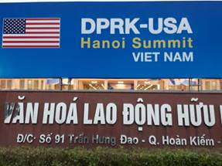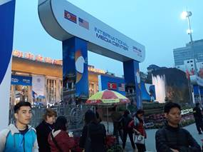

***Vietnam 2.0: From war-torn country to a global peace broker***

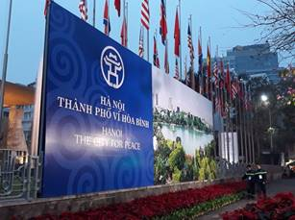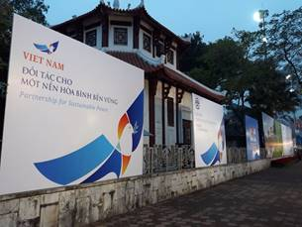

***A media frenzy outside the Kim residence***

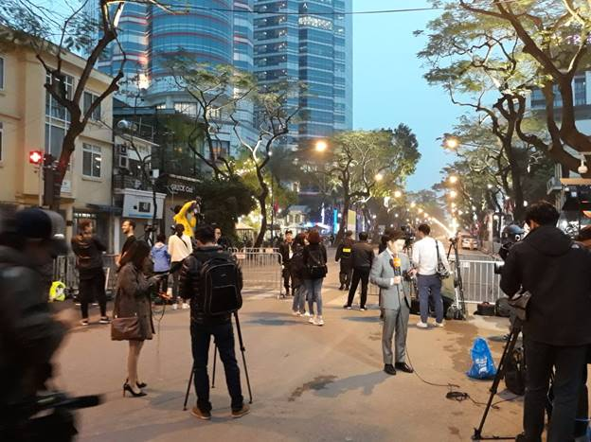

So what does all this mean for the equity investor? Apart from the obvious fact that Vietnam hosting a landmark event of global significance acts as a “sounding board” for Vietnam’s economic ascendance (hopefully, making the typical fund manager’s pitch to his foreign LPs a tad easier), the event – in and of itself – creates opportunities. The sheer following of this event globally implies that it is likely to pique curiosity about Vietnam globally, among travelers and businessmen, alike.

To test whether this hypothesis was true, I looked at worldwide Google search volumes using the keyword “Vietnam” – the chart below speaks for itself.

***Figure: Recent global google search interest by day in the term “Vietnam”***

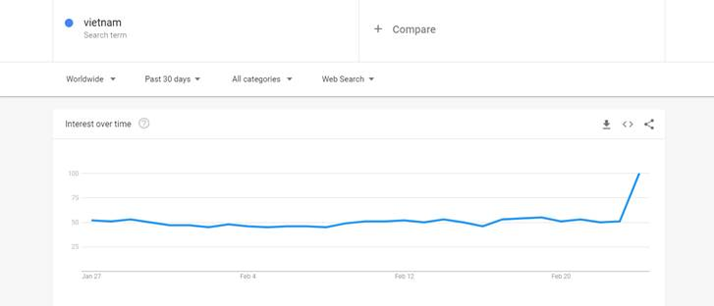

*Source: Google trends*

In fact, search interest in “Vietnam” this week has never been so high in the past 5 years (refer to google’s “dot plot” of the estimated search volume this week)

***Figure: Global google search interest by week  in the term “Vietnam” over the past 5 years***

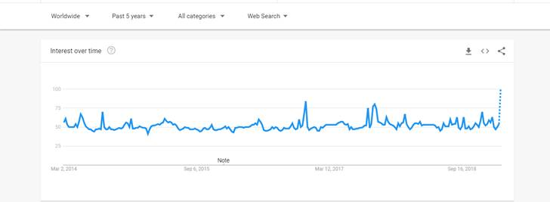

*Source: Google trends*

The “heat map” below also shows you how broad-based the interest in Vietnam is, geographically.

***Figure: Recent global google search interest by week in the term “Vietnam” by source country***

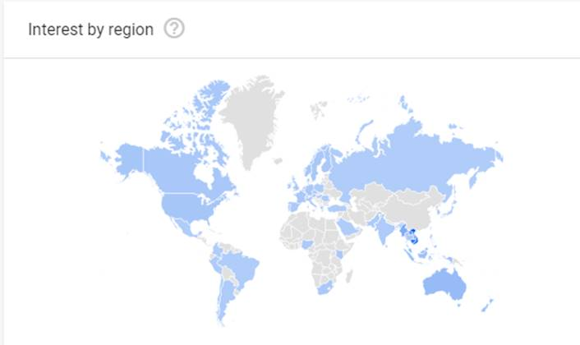

*Source: Google trends*

**Here come the Jet-setters…**

Overall, it appears to me that summit will help boost “Brand Vietnam” and cement the country’s image as a poster child of a country that has successfully transitioned from a closed, command economy to a market-based, trade-oriented economy. This should help attract more manufacturing FDI to the country as companies seek to build a “China plus one” sourcing strategy to mitigate the risk of future trade disputes between China and the US. This could, over time, provide that additional oomph to industrial park operators, logistics and port operators and even air freight / air cargo handling company stocks.

***Figure: Recent global search interest by week in the phrase “Vietnam Factory”***

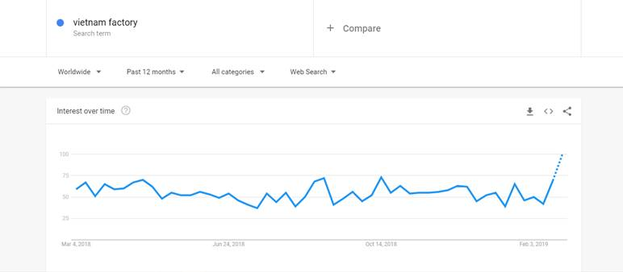

*Source: Google trends*

**…and the Backpackers**

The other major impact would be in terms of boosting Vietnam’s appeal as a tourist destination – many people around the world will be watching this summit and, as alluded to earlier, it should pique their curiosity as travelers, ultimately benefiting foreign tourist arrivals into the country. While there are no direct tourism plays in the Vietnamese stock market, airlines, the monopoly airport operator ACV as well as duty free retailers could benefit from the resulting increase in foreign tourist arrivals. More indirectly, property developers that are active in key tourist hotspots like Phu Quoc, Da Nang should benefit from an appreciation in land prices and potential purchases of “second homes” by foreigners visiting these destinations. Finally, if Bangkok’s mall operators are anything to go by, major Vietnamese retail mall operators like Vincom Retail could also get some lift more foreign tourists visits to their malls in key tourist hubs in the country.

Oh yes, and keep a keen eye on that much-awaited Saigon Tourist IPO.

***Figure: Global search interest by week in the phrase “Vietnam Holiday” over the last five years***

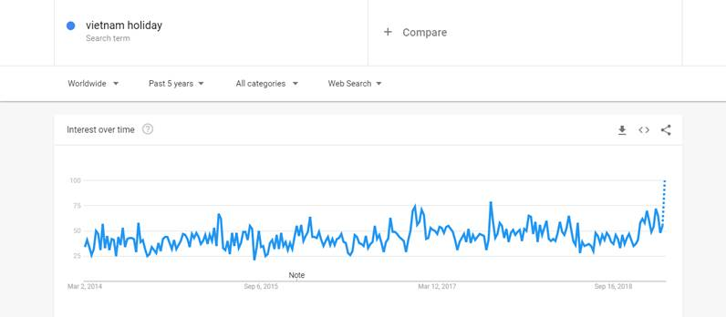

*Source: Google trends*