**An unpleasant sort of Déjà vu for western apparel buyers: Bangladesh’s pain = Vietnam’s gain**

Following the massive Rana Plaza building collapse in Dhaka in 2013 which killed 1,100 garment workers, spooked US and European textile and apparel buyers and drew attention to the plight of garment sector workers in Bangladesh, a flurry of remedial action followed. For a country with a massive – and growing – working age population and a relative dearth of manufacturing employment to absorb them all, thinly-veiled threats from global apparel brands to terminate sourcing contracts from Bangladesh were a rude awakening for the authorities. A frenetic pace of structural checks on factory buildings, working condition audits and the like followed. No news was good news – the regulatory clampdown seemed to be working.

The inferno last week that ripped through a densely packed residential district of Dhaka – while far removed from the textile factory disaster of the past – illustrates that the problems still lurk below the surface. Not least because industrial chemicals were stacked up right next to large apartment blocks from which exposed electric wiring dangled like vines from an Amazonian rainforest. Nine years after the authorities banned the storage of industrial chemicals in residential areas after a huge fire, enforcement continues to be a bottleneck. Judging by this incident, another repeat of the Rana Plaza disaster is more likely than not to occur and the very recognition of this fact is enough to make US and European textile buyers shifty – a very unpleasant sort of Deja Vu.



With Bangladesh being perhaps its closest – and fiercest – competitor in global textile and garment exports, Vietnam is likely to benefit from this renewed skepticism of Bangladesh’s labor and safety standards. With most developed-world customers already jostling for space at the very apex of Maslow’s hierarchy-of-needs pyramid, the desire for self-actualization is increasingly expressing itself through a heightened consciousness of “responsible consumption” – buying brands that support animal testing, developing world sweat shops, deforestation and child labor are an anathema. So, brands take this stuff very seriously. Supply chains are no longer being reconfigured not just based on hard economics and cost arbitrage and this means that Vietnam’s far superior labor safety record and working conditions could well help it overcome its labor cost disadvantage to Bangladesh. With Bangladesh still in the lead in terms of market share, the recent PR crisis for the country’s textile export sector + Vietnam’s recent slew of FTAs mean it is well poised to nibble away at Bangladesh’s lead.

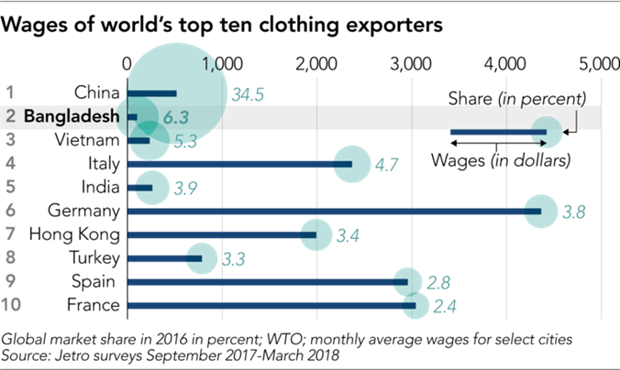

We wrote on the merits of Vietnam’s textile and apparel export sector in our [2019 Navigator report](https://static-02.vndirect.com.vn/uploads/prod/Vietnam_Navigating_2019_20190124.pdf) followed by a [recent update on TCM](https://static-02.vndirect.com.vn/uploads/prod/TCM_Update_20190222_HOLD.pdf), the only fully vertically integrated listed garment exporter in the country. Expect some softness in 2019 owing to one-offs (hence the HOLD rating), but the medium-term story is intact in our view.

**Q1 ETF rebalancing: We smell something fishy**

Not a big proponent of flow-based investing, I nonetheless see an opportunity to make a quick trade on the upcoming rebalancing of both the Van Eck Vectors Vietnam and the FTSE Vietnam ETFs. Lots of tweaks expected here and there but we see the likely inclusion of the pangasius export king VHC into the FTSE ETF as a catalyst for the stock which has seen recent share price weakness after a stellar run-up last year.  Our latest ETF Monitor report can be downloaded [here](https://static-02.vndirect.com.vn/uploads/prod/Marketstrategy_ETFreview_20190222.pdf).

Other names worth highlighting are HPG and MSN, both of which are expected to see strong buying from both the ETFs. VCB is another name worth looking at although the stock has rallied on rock-solid 2018 financial results. A picture is worth more than a thousand words – especially when it comes to ETF rebalancing. So I leave you with our colorful prediction below:

